**East West University**

**Lab Report**

**Semester:** Fall-2024

**Course Title:** Electronic Circuits **Course Code:** CSE251 **Sec:** 03

**Expt No**: 06

**Expt Name:** Single Integration Using 741 Op Amp

**Group No:** 07

**Submitted by-**

Name: Sheikh Sarafat Hossain

Id: 2022-3-60-109

**Submitted to-**

Dr. Sarwar Jahan

Associate Professor

Department of Computer Science & Engineering

East West University

**Date of Performance:** 02-01-2025

**Date of Submission:** 16-01-2025

**Objectives:**

1. To study the responses of Op-Amp integrator to sinusoid and square waveforms

**Circuit Diagram:**

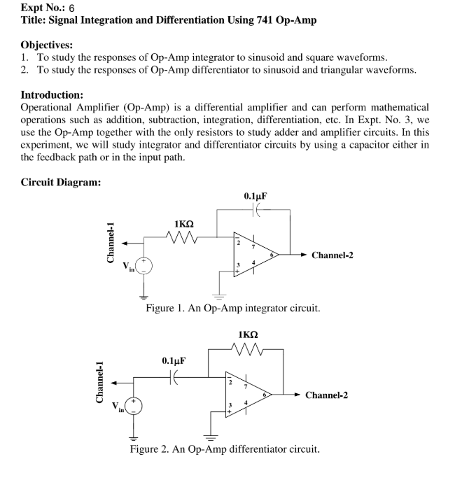

**Answer to the Pre-Lab Questions:**

Here Given,

Vin​=Vp​sin(ωt)

R= 1kΩ = 1000Ω,

C= 0.1µF = 0.1×10−6 F

**So,** Vout​(t) = − $\frac{1}{RC}$ ​∫Vin​(t)dt

= − $\frac{1}{RC}$ ​∫ Vp​sin(ωt) dt

= − $\frac{Vp}{RCω}$ ​(−cos(ωt))

Vout​(t) = $\frac{Vp}{RCω}$ ​(cos(ωt))

Since ω=2πf, we rewrite:

Vout​(t) = $\frac{Vp}{RCω}$ ​(cos(2 $π$ ft))

Again, the given output amplitude is 2Vp

So, Aout =

or, 2Vp =

or , $\frac{1}{RCω}$ =2

or, ω = $\frac{1}{2RC}$

or, f = $\frac{1}{4πRC}$

f = $\frac{1}{4 x 3.1416 x 1000 x 0.1×10-6 }$ = 795.77 Hz

|  |  |  |
| --- | --- | --- |
| Type of wave | Amplitude | Phase Difference |
| Sine Wave | Channer 1: 2.24 V  Channer 2: 2.16 V | 210 µs |
| Square wave | Channer 1: 2.01 V  Channer 2: 2.16 V | 450 µs |

**The input and output waveforms in voltage and time:**

**Answer to the Post-Lab Questions:**

Here , Vp = 2V, R = 1kΩ , C= 0.1 µF

But our measured value of R = 0.98 kΩ

1. Vout​(t) = $\frac{Vp}{RCω}$ ​(cos(2 $π$ ft))

= $\frac{2}{0.98 x 0.1×10-6 x (2π x 795.77)}$ ​(cos(2 $π$ x 795.77 t))

= 4.32 cos (2π×795.77×t) V

1. Vout = 2 x Vp

= 2 x 2.16

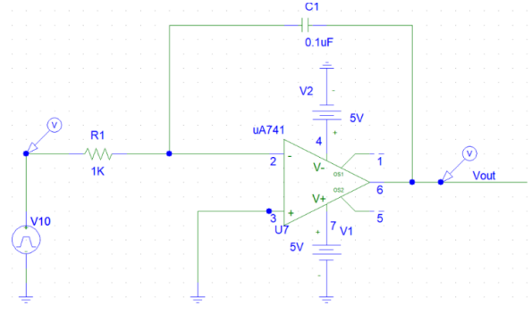

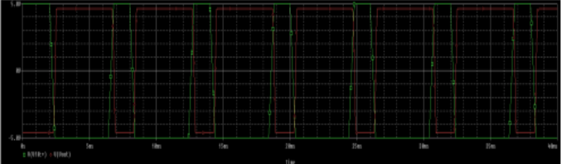

**Discussion:**

